Test Case: tc006_SPX_Dev5_Crear_Requisicion_Spot_Tipo_Cobro_Proyect_Urgent
Step 1 - Enter username and password and click to button Enter: Credentials Entered
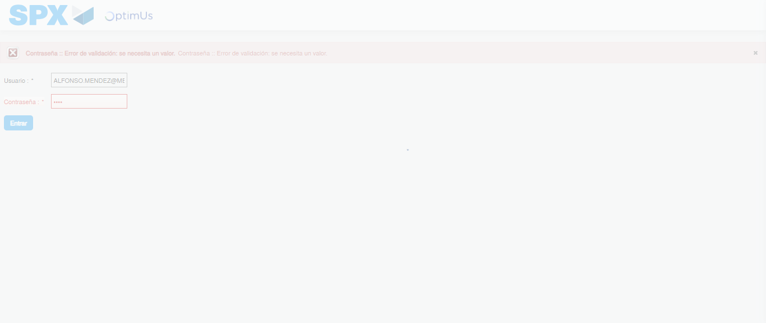Image file-name: QC_Testing-tc006_SPX_Dev5_Crear_Requisicion_Spot_Tipo_Cobro_Proyect_Urgent-1783377493269

Step 2 - Select to UEN and Access to Spot Buy Requisitions : UEN Correctly selected and Correct access
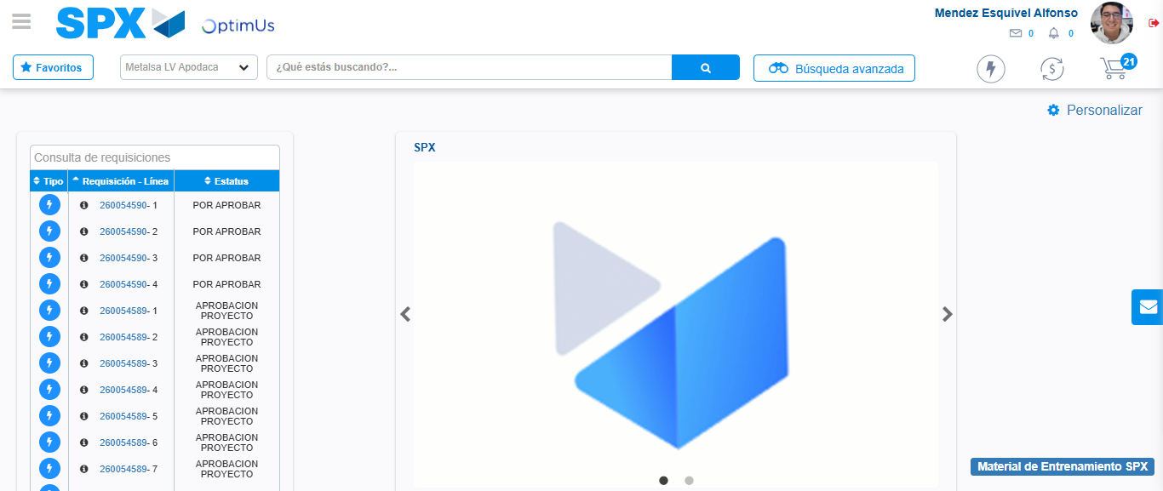Image file-name: QC_Testing-tc006_SPX_Dev5_Crear_Requisicion_Spot_Tipo_Cobro_Proyect_Urgent-1783377518935

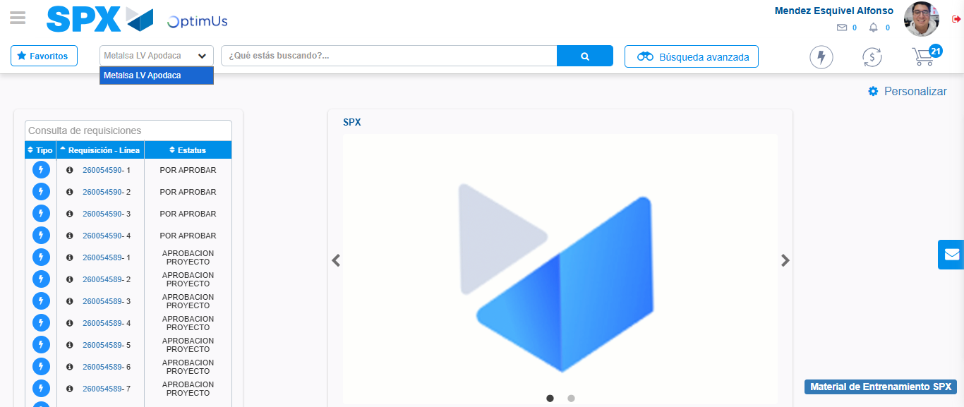Image file-name: QC_Testing-tc006_SPX_Dev5_Crear_Requisicion_Spot_Tipo_Cobro_Proyect_Urgent-1783377521369

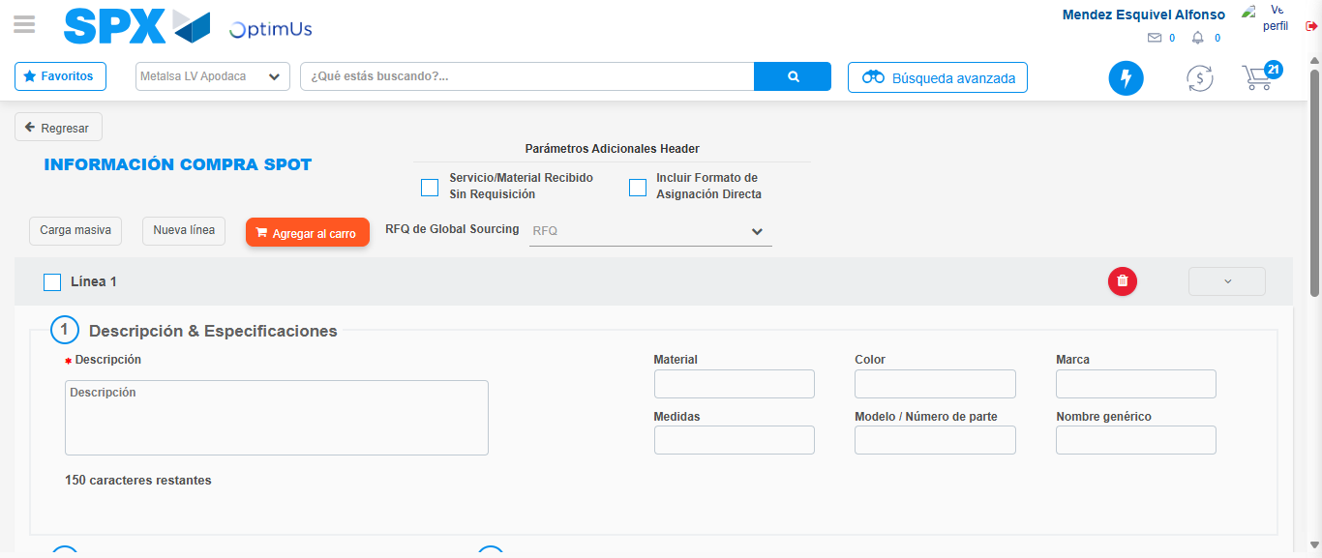Image file-name: QC_Testing-tc006_SPX_Dev5_Crear_Requisicion_Spot_Tipo_Cobro_Proyect_Urgent-1783377544643

Step 3 - Data Capture Spot Buy Requisition: Data captured correctly
Image file-name: QC_Testing-tc006_SPX_Dev5_Crear_Requisicion_Spot_Tipo_Cobro_Proyect_Urgent-1783377544868

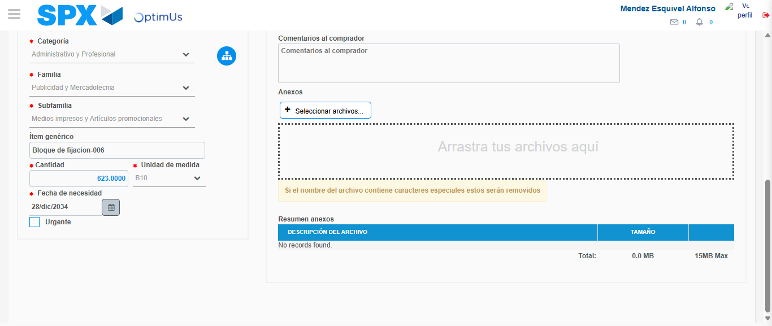Image file-name: QC_Testing-tc006_SPX_Dev5_Crear_Requisicion_Spot_Tipo_Cobro_Proyect_Urgent-1783377555558

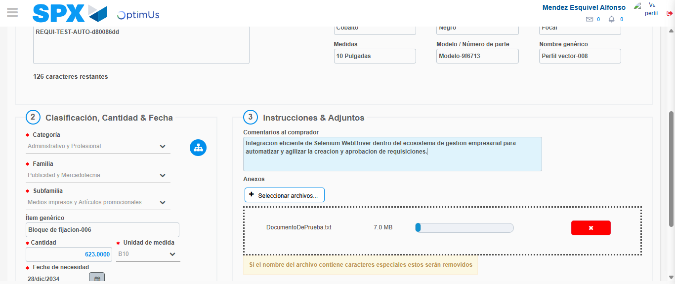Image file-name: QC_Testing-tc006_SPX_Dev5_Crear_Requisicion_Spot_Tipo_Cobro_Proyect_Urgent-1783377556273

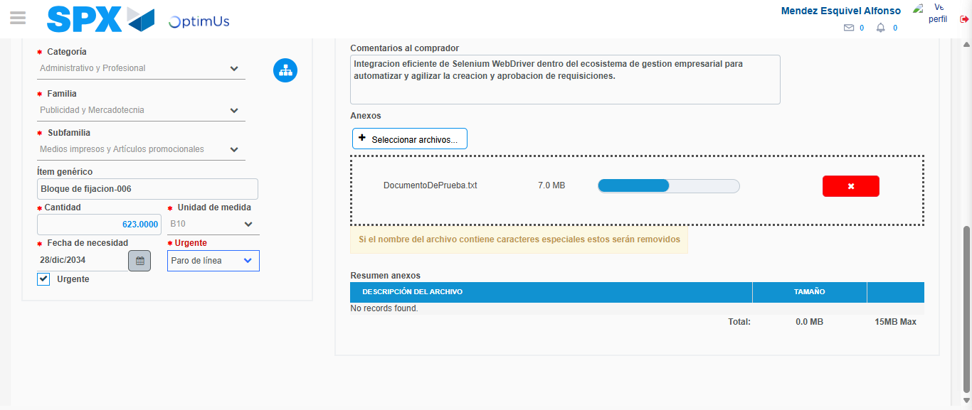Image file-name: QC_Testing-tc006_SPX_Dev5_Crear_Requisicion_Spot_Tipo_Cobro_Proyect_Urgent-1783377559348

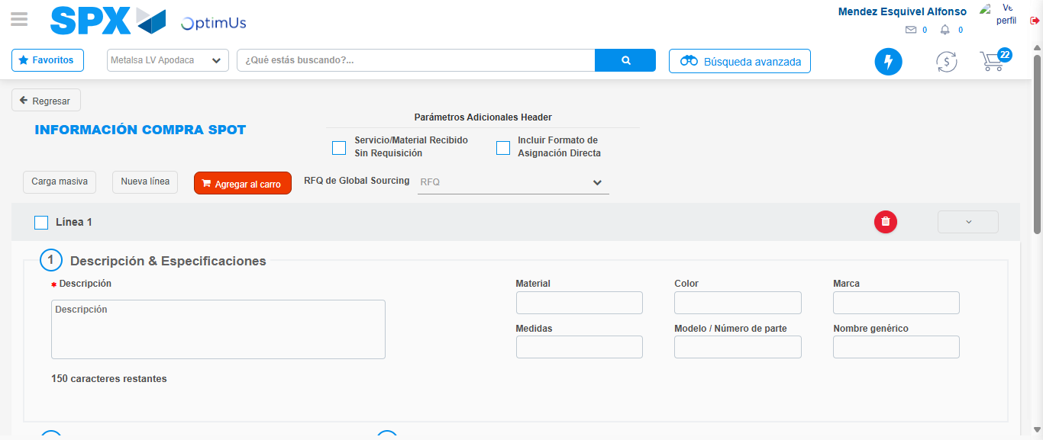Image file-name: QC_Testing-tc006_SPX_Dev5_Crear_Requisicion_Spot_Tipo_Cobro_Proyect_Urgent-1783377566794

Step 7 - Return to Main Page SPX : Return to Main Page SPX
Image file-name: QC_Testing-tc006_SPX_Dev5_Crear_Requisicion_Spot_Tipo_Cobro_Proyect_Urgent-1783377518935

Image file-name: QC_Testing-tc006_SPX_Dev5_Crear_Requisicion_Spot_Tipo_Cobro_Proyect_Urgent-1783377521369

Image file-name: QC_Testing-tc006_SPX_Dev5_Crear_Requisicion_Spot_Tipo_Cobro_Proyect_Urgent-1783377544643

Image file-name: QC_Testing-tc006_SPX_Dev5_Crear_Requisicion_Spot_Tipo_Cobro_Proyect_Urgent-1783377569024

Image file-name: QC_Testing-tc006_SPX_Dev5_Crear_Requisicion_Spot_Tipo_Cobro_Proyect_Urgent-1783377569175

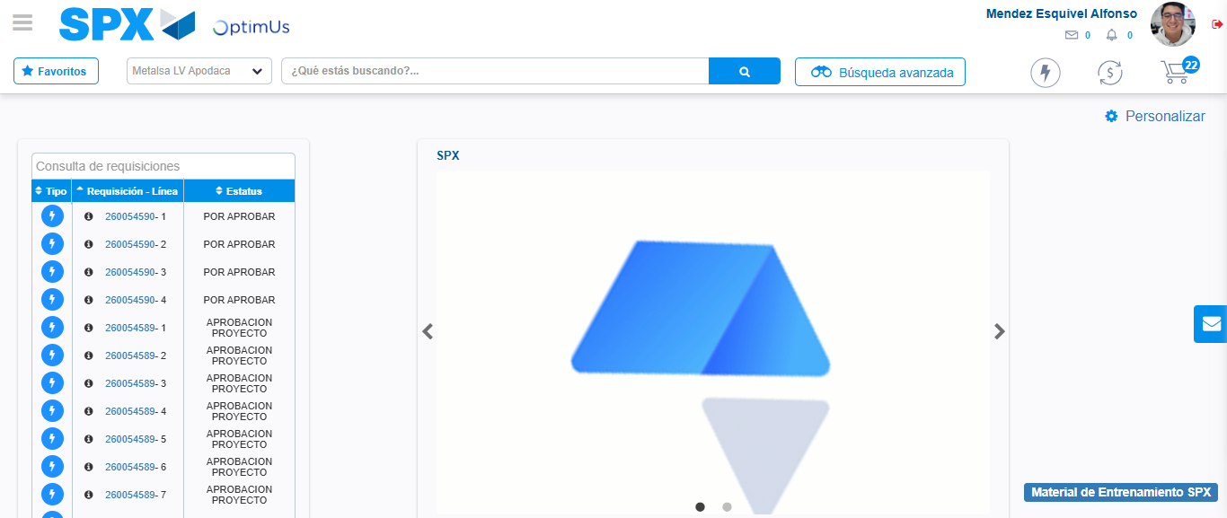Image file-name: QC_Testing-tc006_SPX_Dev5_Crear_Requisicion_Spot_Tipo_Cobro_Proyect_Urgent-1783377590194

Step 8 - Log Out : Log Out SPX
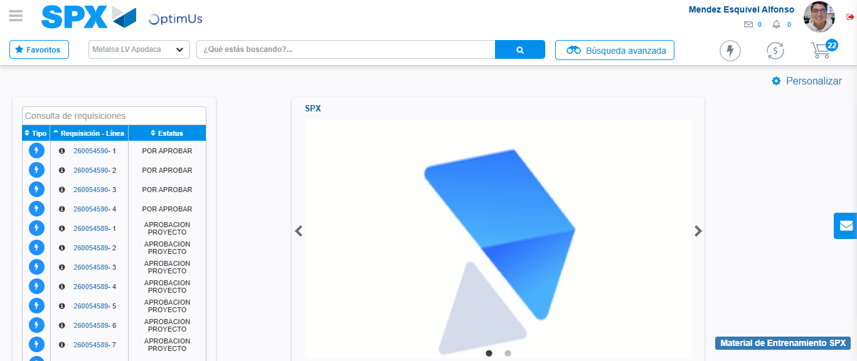Image file-name: QC_Testing-tc006_SPX_Dev5_Crear_Requisicion_Spot_Tipo_Cobro_Proyect_Urgent-1783377590443

